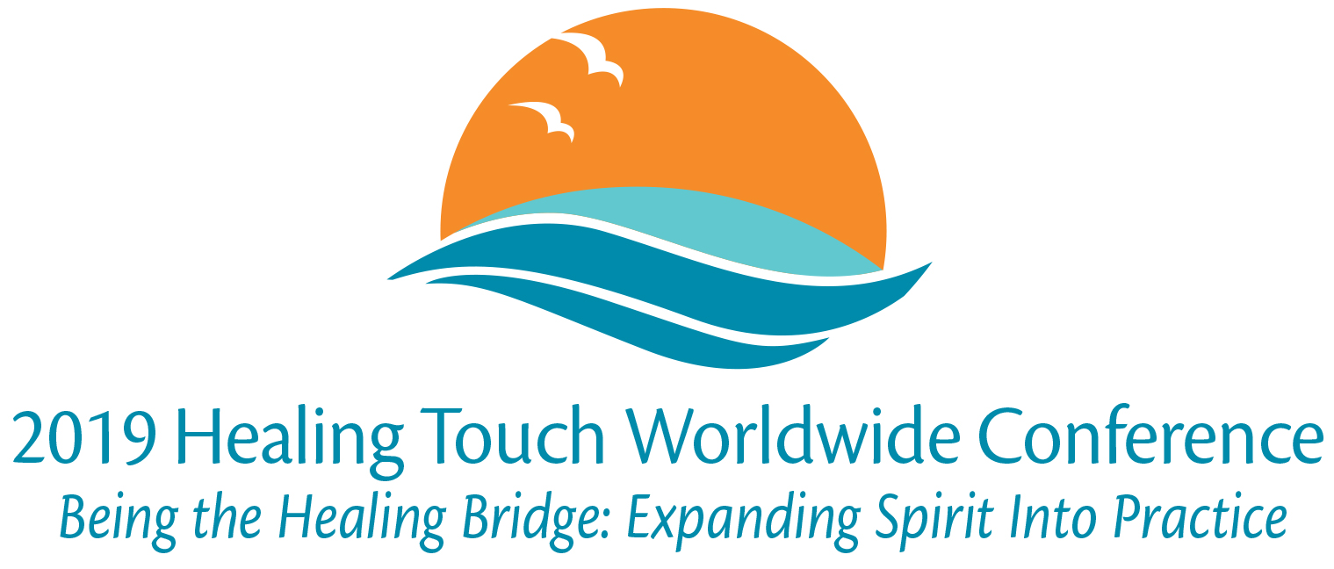

2019 Conference Pinning Form

Practitioner Pinning for HTP, HTA, ISHA
If you are a newly certified practitioner, or have not received your practitioner pin, and would like to be pinned at conference, please complete the following information. The Pinning Ceremony will take place on Friday evening following the Opening Ceremony.

First Name: Last Name:
Date of practitioner certification:
Name of Mentor or person pinning you:
Organization: HTP HTA ISHA

HTP Instructor Pinning
Newly Certified Instructors: If you are going to be pinned during the Instructor Gathering, please complete the following information. We will acknowledge all newly pinned instructors during the Main Conference Pinning Ceremony on Friday evening.

First Name: Last Name:
Date of instructor certification:

HTP Instructor Anniversary Pin
Celebrating a 5, 10, 15, 20, 25 or 30 year Anniversary? If you will receive your anniversary pin during the Instructor Gathering, please complete the following information. We will acknowledge all instructors celebrating an anniversary during the Main Conference Pinning Ceremony on Friday evening.

First Name: Last Name:
Year of instructor certification:
Anniversary pin to be received:
5 year 10 year 15 year 20 year 25 year 30 year

Questions or comments:

Please email this form to conference@healingtouchprogram.com

