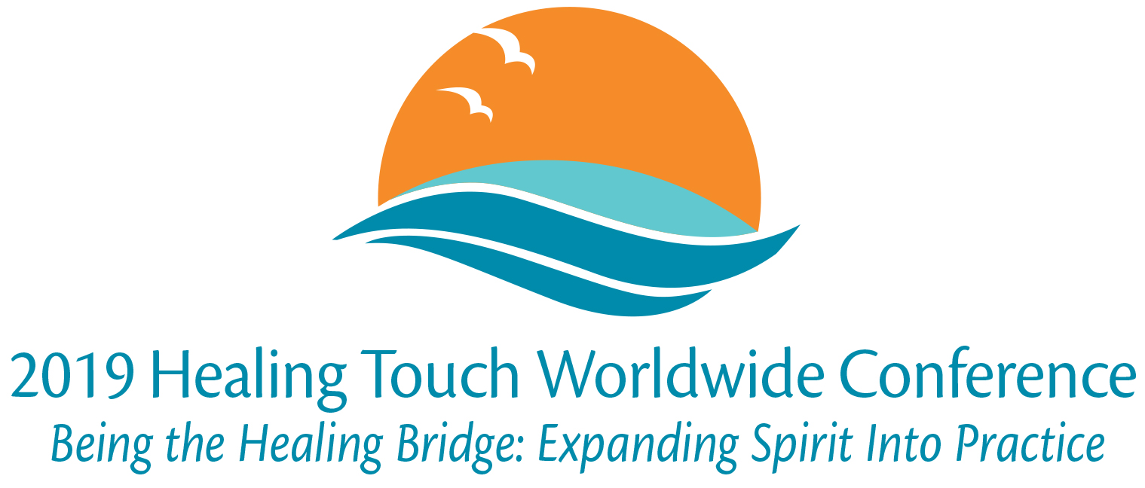

Poster Submission Application

HTP is excited to offer poster presentations at the 2019 Healing Touch Worldwide Conference. Posters should have Healing Touch, other biofield energy therapies or integrative medicine as the topic and may be research or non-research.

Posters will be displayed at the conference in the lobby. There will be designated times for attendees to talk with poster presenters during breaks on Saturday and Sunday. The person submitting the poster, or their designated attendee, will need to be present for individual discussion and to answer questions.

Continuing education contact hours will be offered. The content of the poster must enable the learner to acquire or improve knowledge or skills beyond basic knowledge and enhance professional development or performance. Poster content must have one learning objective.

If available, please provide a PDF of the poster with the application.

To submit a poster for consideration, complete the application below and return it by December 17, 2018 to conference@healingtouchprogram.com.

You will receive an email notification of acceptance with information for shipping your poster within one week of receipt. If you are not contacted within a week, please call the HTP office at 210-497-5529 to confirm that your application was received.

For questions please email conference@healingtouchprogram.com.

Thank you, HTP Conference Team

Name:
Employer / Organization:
Position / Title:
Credentials:
Email:
Phone:

Poster Title:
Is this a research poster? Yes OR No
Learning Objective:
Is a PDF of the poster being submitted? Yes OR No
Poster size:
Brief description of poster (~30 words)

